**Question 1:**

Ratio = 0.698

Python Script:

from __future__ import division

if __name__ == '__main__':

try :

with open('REVISEDPUMS5_36.txt') as myfile:

total_count = sum(1 for line in myfile)

with open('REVISEDPUMS5_36.txt') as myfile:

total_count_p = sum(1 for line in myfile if line.rstrip().startswith('p') or line.rstrip().startswith('P'))

print "Ratio :", round(total_count_p/total_count,3)

except:

print "Main Program Aborted"

**Question 2:**

**Should U.S. decrease Oil production?**

Anatomy of the oil price fall

As world came to terms with the dastardly act in Paris, the U.S. stocks gained on Monday. The jump was bolstered by intra day rise in oil prices. International crude oil prices are close to levels last seen in 2009, when the global economy was gripped by its worst slump since the 1930s.



(*source macrotrends.net)

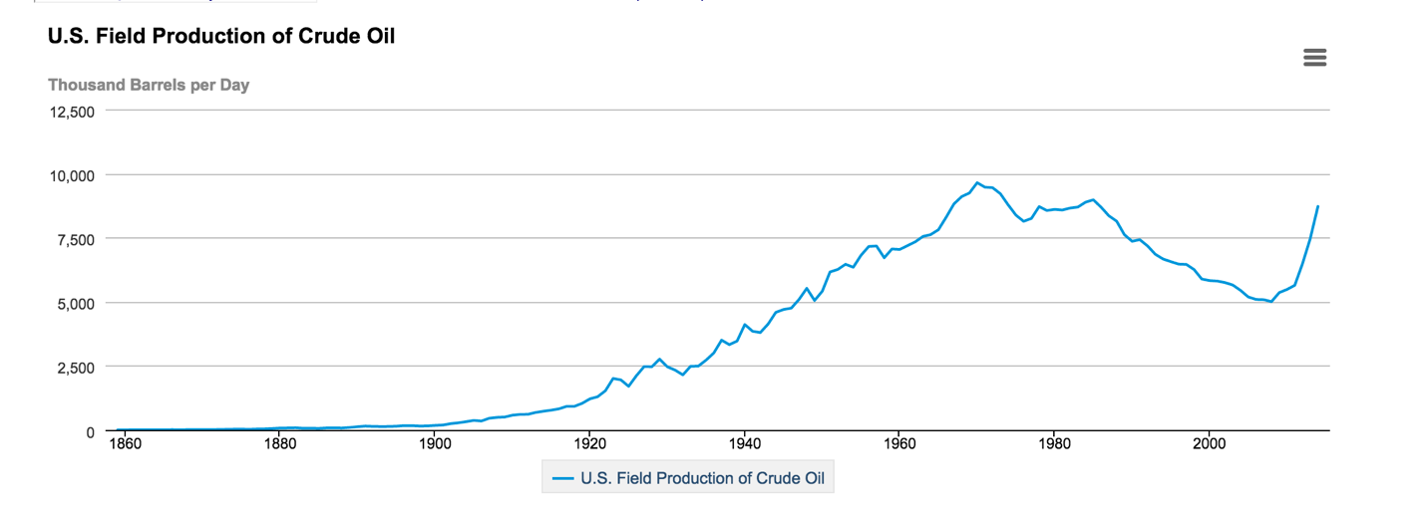

(*source http://www.eia.gov/dnav/pet/hist/LeafHandler.ashx?n=pet&s=mcrfpus2&f=a)

The remarkable fall in global oil prices is continuing because of a mismatch in demand and supply. Demand is down because of eurozone’s economic stagnation, Japan’s slipping into recession and China’s slowdown. Output, on the other hand, is rising on account of the U.S. shale boom.  America’s oil output has steadily increased since 2008 and is at all time high in last 20 years.

So is this increase in oil production sustainable and useful in a long term?

Energy gained is Energy lost

The law of conservation of energy states that energy gained is energy lost. The field of financial theory has drawn lot of inspiration from natural physical laws. Increase in oil production leading to oil price fall has suited the American consumers. Cheaper fuel price has put more money in the hands of consumers. But all this is a short term gain. The oil market was funded in a major way in the last few years by cheap dollars flowing out of the Federal Reserve’s quantitative easing program. With interest rates at near zero, surplus funds flowed into the commodity markets, notably crude oil, driving their prices upwards. But as Fed prepares to increase the interest rate, the cheap dollars may dry out. This ultimately can lead to sudden increase in oil prices. In such a scenario the higher oil production may lead to an economic breakdown. Thus the short term gains to the consumer may well prove to be costlier in long term.

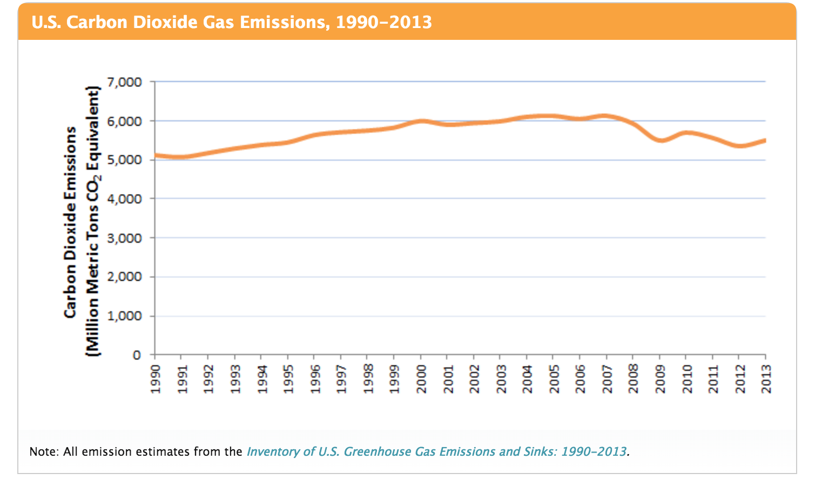

(source * http://www3.epa.gov/climatechange/ghgemissions/gases/co2.html)

The Not (So) good Carbon

Decrease in oil prices has also taken a toll on environment. There has been a clear correlation with increase in carbon dioxide emission and decrease in oil prices. The combustion of fossil fuels such as gasoline and diesel to transport people and goods is the second largest source of carbon emissions, accounting for about 31% of total U.S.  An increased use of fossil fuel has been a major contributor to the increase in carbon emission.

Fractured Mandate:

Increase in oil production has been accomplished by enhancing old hydraulic fracturing techniques. Such new methods have lead to water contamination, climate change, noise pollution and health effects on human. Thus higher levels of oil production are clearly not sustainable from an environmental point of view.

Conclusion

The long term detrimental effects on economy and environment clearly overshadow the short term benefit from the increased oil production. The environmental damages are clearly irreversible and cannot be compensated by short term economic gains. Thus taking into account the above points it makes most sense for U.S. to cut down oil production.